Project Repot
1. INTRODUCTION
1.1 Project Overview
EduGenie is an AI-powered learning assistant built using FastAPI, React, and Google Gemini 3.5 Flash Lite. It helps students learn efficiently through 5 intelligent tasks: Q&A, Explain Concept, Generate Quiz, Summarize Text, and Recommend Learning Path. The project is deployed on Render and handles real-time content generation within 3 seconds.

1.2 Purpose
The purpose of EduGenie is to solve the problem of scattered learning resources. Students struggle to find quick answers, simplified explanations, practice quizzes, summaries, and personalized roadmaps. EduGenie provides all-in-one solution with AI, reducing learning time and improving understanding.
2. IDEATION PHASE
2.1 Problem Statement
Students often face difficulty in understanding concepts, clearing doubts, revising lengthy study materials, and preparing for assessments. They need a single platform that provides simple and personalized learning support.
Problem Statement (PS) | I am | I’m trying to | But | Because | Which makes me feel
PS-1 | A Student | Understand difficult topics. | I find it difficult to get it clear and simple explanations. | Learning resources are scattered and may not match my level. | Confused and takes more time to study.
PS-2 | A Student | Revise and practice my lessons. | Creating summaries and quizzes manually takes time. | I need to prepare different study materials separately. | Less organized during exam preparation.

2.2 Empathy Map Canvas
An Empathy Map is a visual tool to understand our target user - College Student. It helps us understand his thoughts, feelings, pains and gains to design EduGenie as an all-in-one learning solution
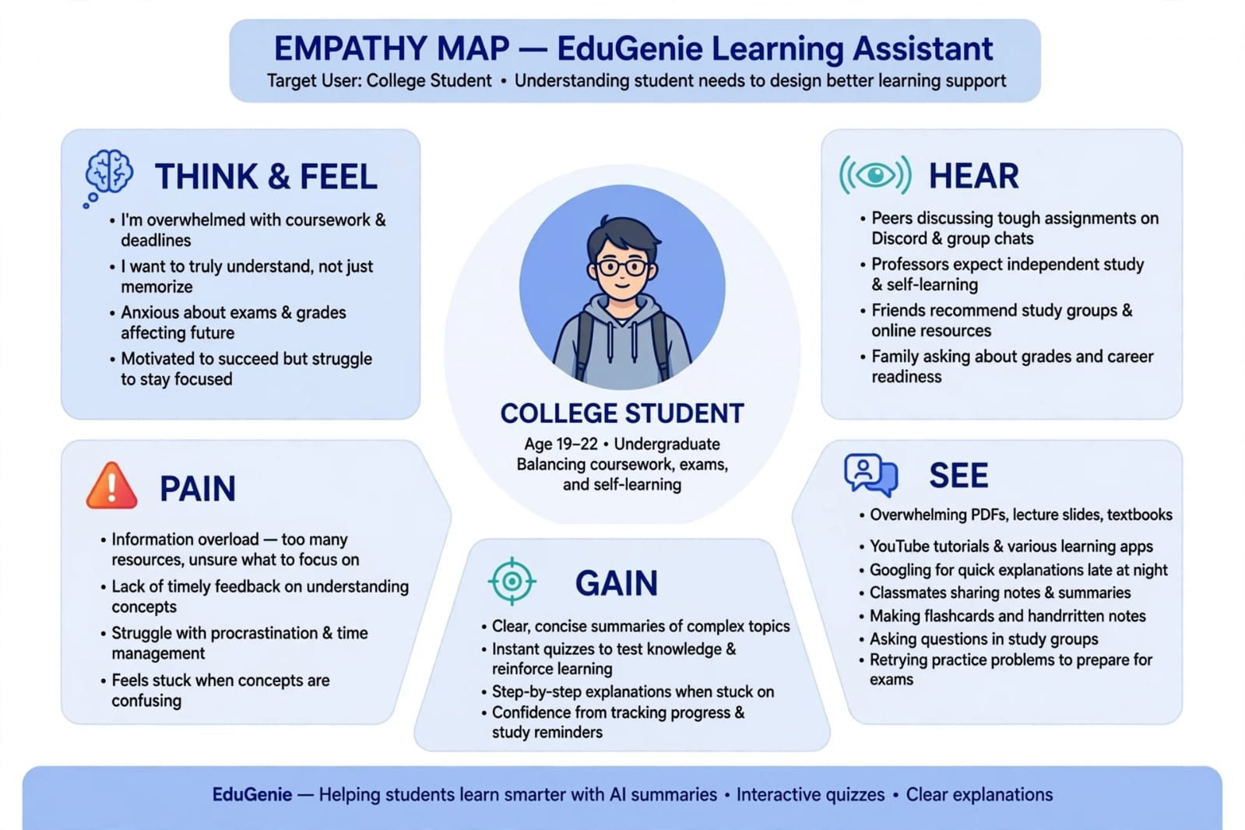
2.3 Brainstorming
Brainstorm, Idea Listing and Grouping
Category | Idea | Purpose
Doubt Support | Q&A | Provides quick answers to students’ questions and doubts.
Concept Learning | Explanation | Explains difficult concepts in a simple and understandable way.
Assessment | Quiz Generation | Generates quizzes based on the selected topic or learning content.
Content Support | Summarization | Converts lengthy study material into concise points.
Personalized Learning | Learning Path Recommendation | Provides a step-by-step learning path based on the student’s needs.
Grouping: Doubt Support → Q&A | Concept Learning → Explanation | Assessment → Quiz Generation | Content Support → Summarization | Personalized Learning → Learning Path Recommendation
Idea Prioritization
Idea | Priority | Reason
Q&A | High | Helps students get quick answers to doubts.
Explanation | High | Makes difficult concepts easier to understand.
Quiz Generation | High | Helps students practice and assess their knowledge.
Summarization | Medium | Helps students quickly understand lengthy content.
Learning Path Recommendation | Medium | Provides a structured approach for learning.

3. REQUIREMENT ANALYSIS
3.1 Customer Journey Map

Stage | What Student Does
Awareness | Students needs help for tough subject
Consideration | Checks EduGenie- has 5 things
Usage | 1.Concept Explain,  2.Q&A,  3.Summary,  4.Quiz,  5.Learning path recommendation
Retention | Daily uses Learning Path to study
Advocacy | Shares with friends

3.2 Solution Requirement
Functional Requirements:
Following are the functional requirements of the proposed solution.
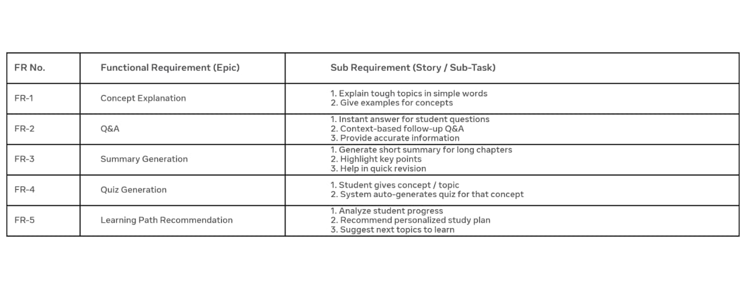

Non Functional Requirements:
Following are the non functional requirements of the proposed solution. 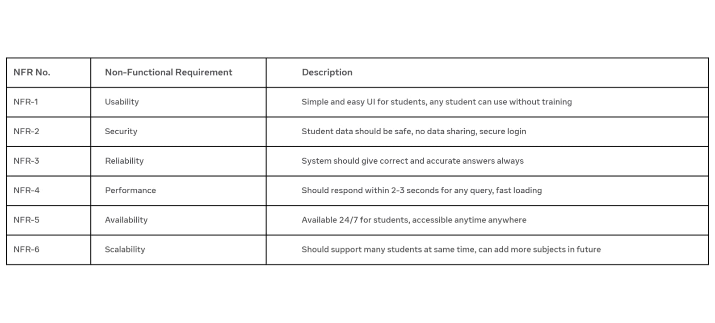
3.3 Data Flow Diagram

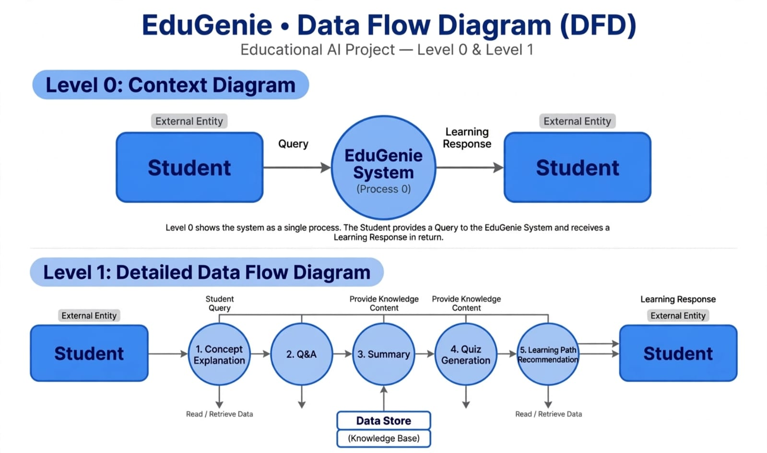
How the Data Flow Diagram Works :
1.Level 0: Context Diagram (Simple Flow)This shows the system as a single process.The Student (External Entity) sends a Query (e.g., "Explain Photosynthesis") to the EduGenie System.
2.The EduGenie System processes the query.
3.The System sends back a Learning Response to the Student.It is a simple input and output cycle.
Level 1: Detailed Flow (How the 5 Concepts Work)
When a student asks a doubt, the data flows through 5 main processes:
1. Concept Explanation: The system retrieves data from the Knowledge Base and explains the tough concept in simple terms.
2. Q&A: It handles follow-up questions from the student and provides instant, accurate answers.
3. Summary: It accesses long content from the Data Store and generates a short, easy-to-revise summary.
4. Quiz Generation: It creates practice questions from the same topic to test the student's understanding.
5. Learning Path Recommendation: Finally, it analyses the student's progress and recommends a personalized learning path.
All 5 processes Read / Retrieve Data from the Data Store (Knowledge Base), which stores all the learning content.
After processing through all 5 concepts, a complete Learning Response is sent back to the Student.

User Stories
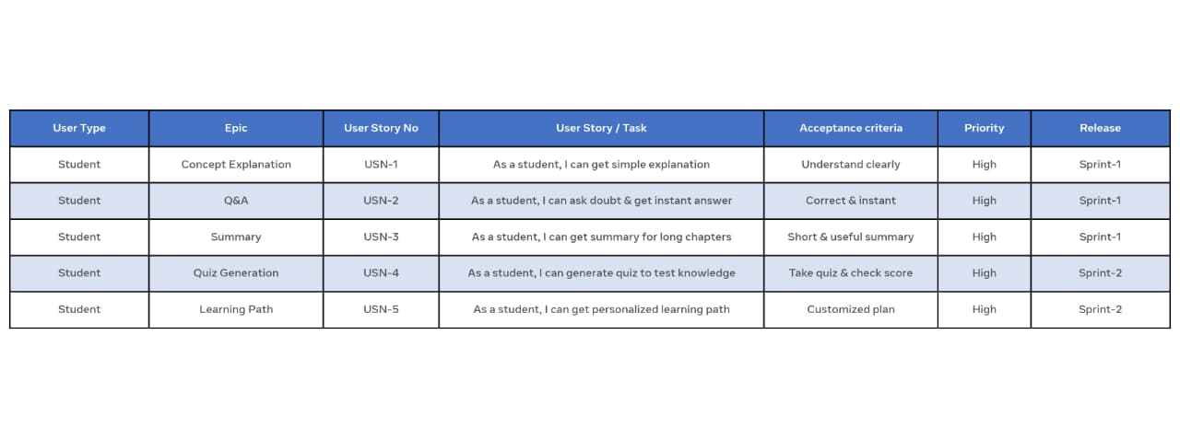
3.4 Technology Stack
Technical Architecture:
The technical architecture of EduGenie defines the high-level structure of the system, including the presentation layer, application logic layer, AI model integration layer, and infrastructure layer. It illustrates the flow of data between user interface, FastAPI backend built with Python 3.14.4 and Jinja templates, and the external Gemini 3.5 Flash Lite API for intelligent content generation.
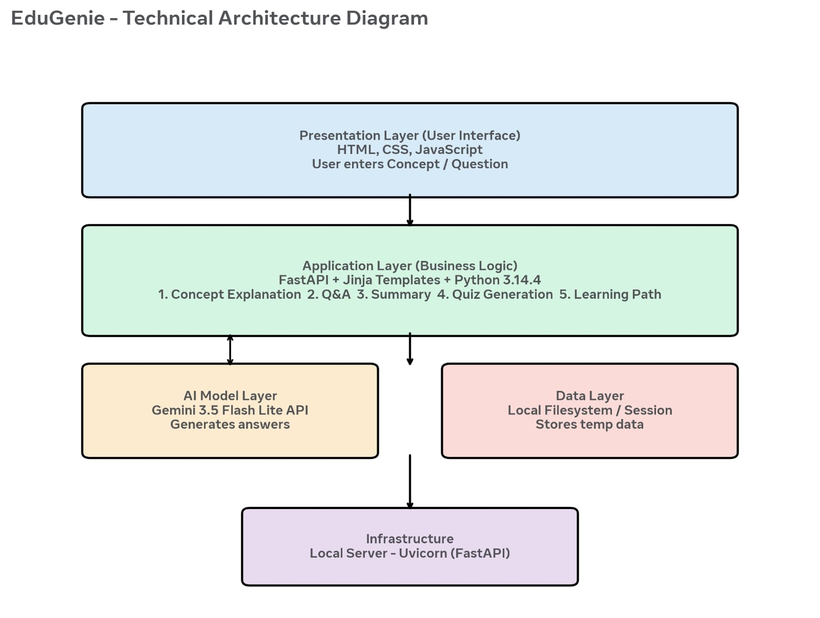
Components and Technologies
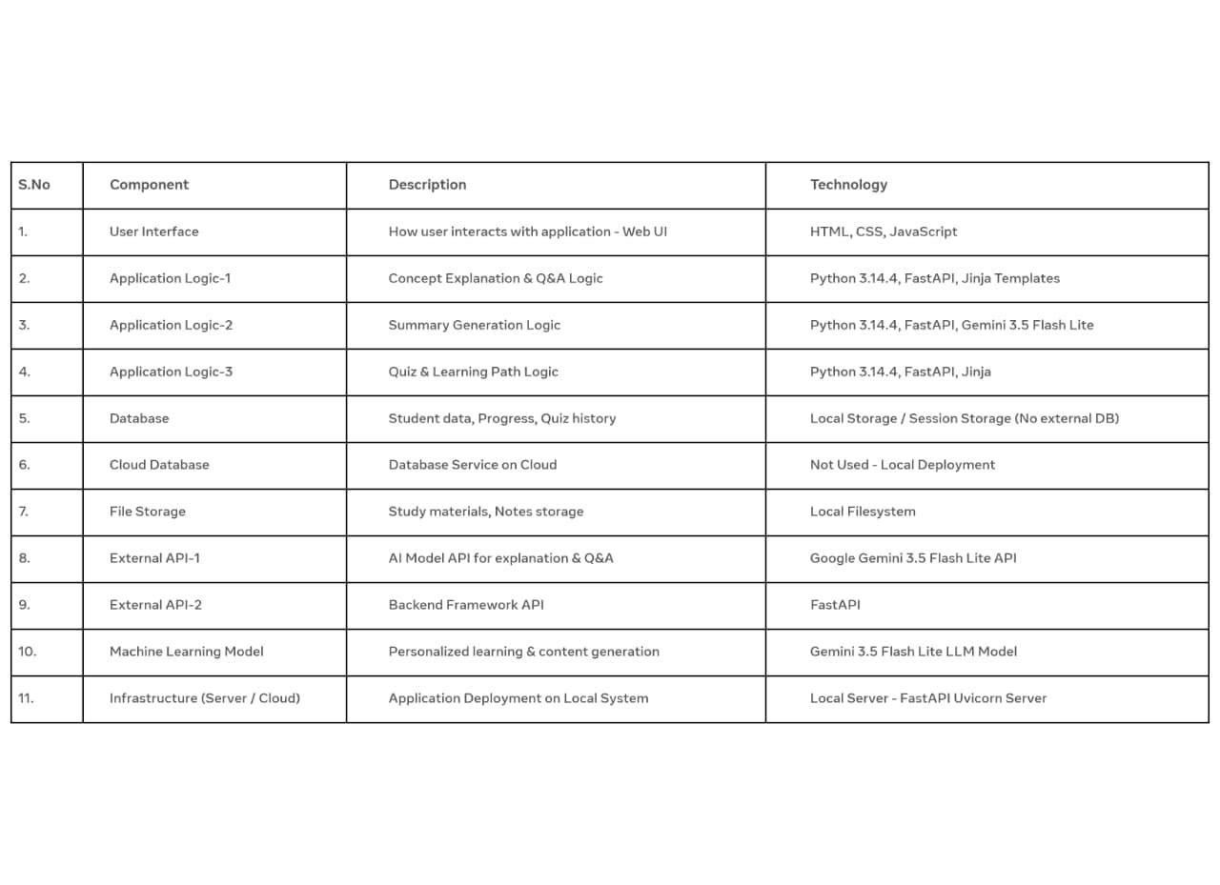
Application Characteristics:
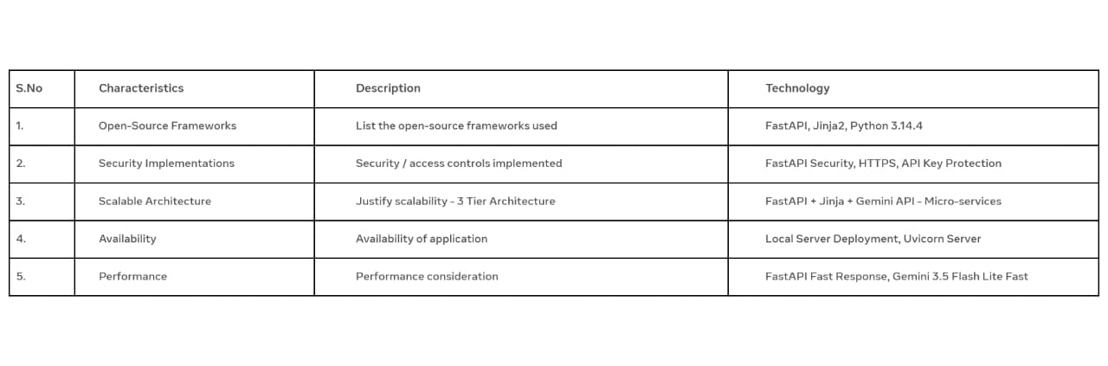4. PROJECT DESIGN

4.1 Problem Solving Fit
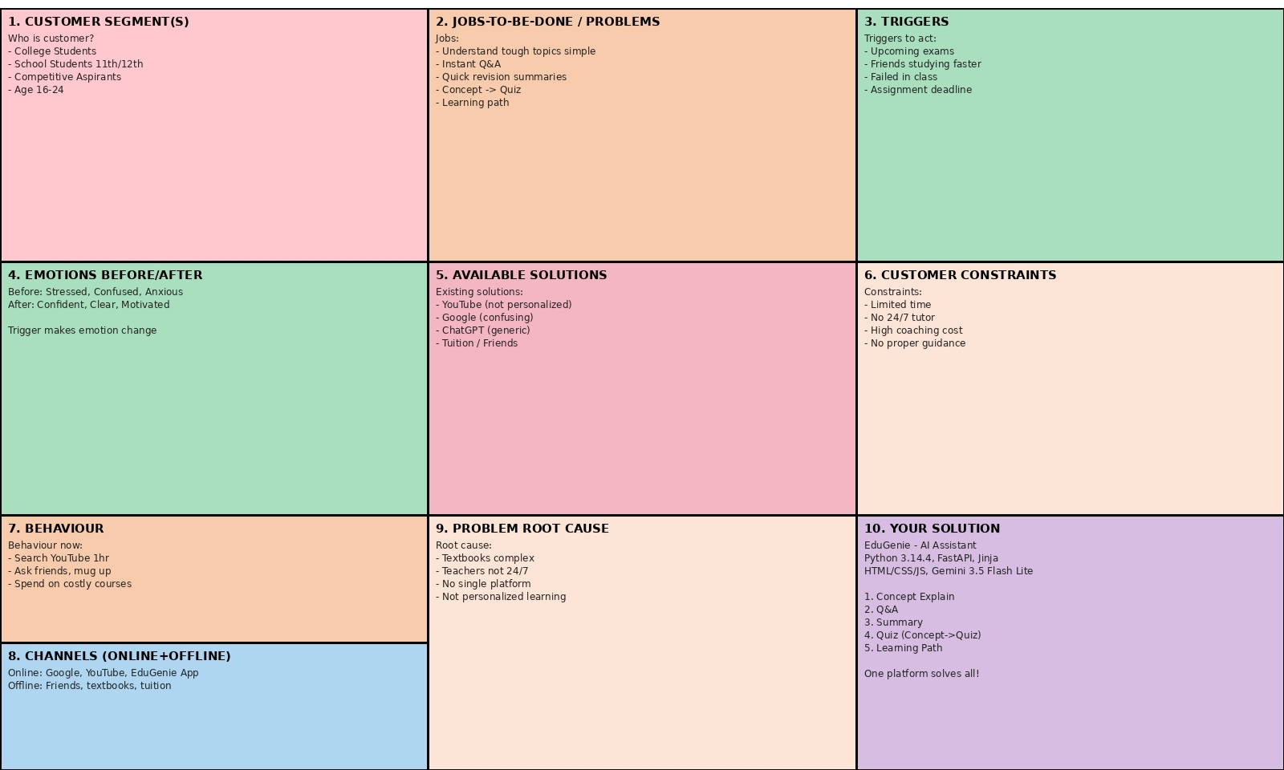
4.2 Proposed Solution

S.NO | PARAMATER | DESCRIPTION
1. | Problem Statement | Students struggle to understand complex academic concepts due to tough textbook language, lack of 24/7 personal tutor, and no single platform for explanation, doubt clearance, summary and testing. They waste hours on YouTube/Google getting generic answers, leading to stress and poor performance.
2. | Idea / Solution description | EduGenie - AI Powered Learning Assistant. Tech: Python 3.14.4, FastAPI, Jinja, HTML/CSS/JS, Gemini 3.5 Flash Lite API. Features: 1) Concept Explanation simple, 2) Instant Q&A, 3) Summary Generation, 4) Quiz Generation (Concept->Quiz), 5) Learning Path. Single FREE platform.
3. | Novelty / Uniqueness | 1. Unique Concept->Quiz feature - no other FREE tool does this. 2) 5 features in ONE FREE platform. 3) Built on Gemini 3.5 Flash Lite - fast, accurate. 4) FastAPI+Jinja lightweight - response <3 sec. 5) Completely FREE for rural students.
4. | Social Impact / Customer Satisfaction | Helps 16-24 age students from rural/urban areas get FREE 24/7 tutor, reduces stress, saves money on coaching (saves Rs.5000/month). Instant FREE answers, personalized learning, quiz builds confidence. Makes quality education accessible to ALL. Students feel Confident, Clear, Motivated.
5. | Business Model (Revenue Model) | FREE & Social Service Model - NO MONEY CHARGED. Currently completely FREE for all students. No Freemium, No Premium, No Ads. Developed as non-profit educational initiative. Cost minimal (Gemini free tier, Render free hosting). Future Sustainability: Through open-source support, college grants, or government schemes, but core platform will ALWAYS remain FREE. Success measured by students helped, not profit.
6. | Scalability of the Solution | Highly Scalable even as FREE: 1) FastAPI handles 1000+ requests/sec. 2) Gemini API auto-scales. 3) Stateless design - deploy on Vercel/Render/AWS free. 4) Can move to Firebase free for millions of users. 5) Can add more FREE features without architecture change. Can serve 1 Lakh+ students with almost zero cost.

4.3 Solution Architecture
Solution architecture is a complex process that bridges the gap between business problems and technology solutions. Its goals are to:
- Find the best tech solution to solve existing business problems (Students lack of tutor)
- Describe the structure, characteristics, behaviour of EduGenie to stakeholders
- Define features (5 features), development phases, and solution requirements
- Provide specifications according to which solution is defined, managed, and delivered
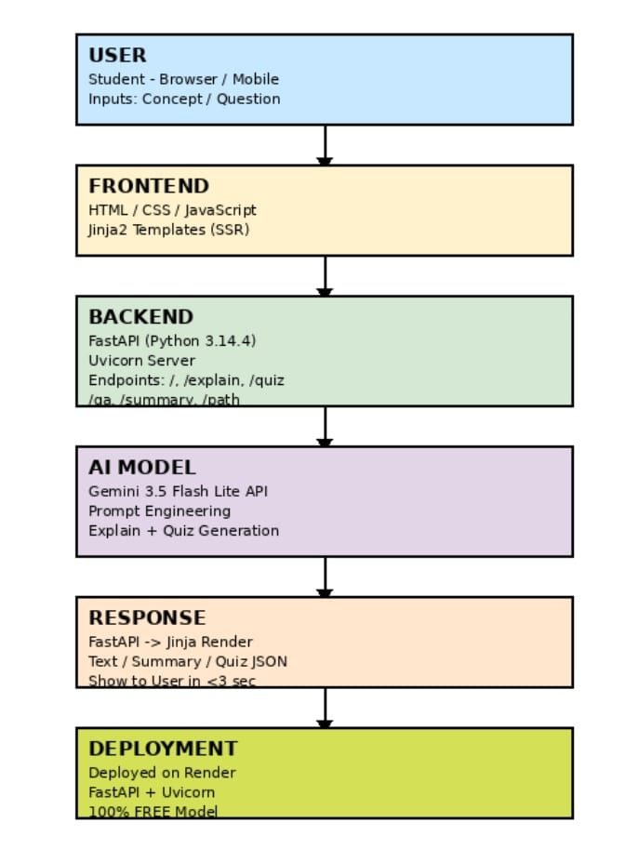
Data Flow:
1. Student enters concept in Browser
2. HTTP Request goes to FastAPI Backend (Python 3.14.4 + Uvicom)
3. FastAPI calls Gemini 3.5 Flash Lite API with engineered prompt
4. Gemini retuns explanation/quiz/ summary/qna/learning path
5. FastAPI fomats response using jinja2 template
6. Response rendered to user browser in <3 seconds
7. Process completes, ready for next request
5.PROJECT PLANNING & SCHEDULING
5.1 Project Planning
Product Backlog,Sprint Schedule and Estimation

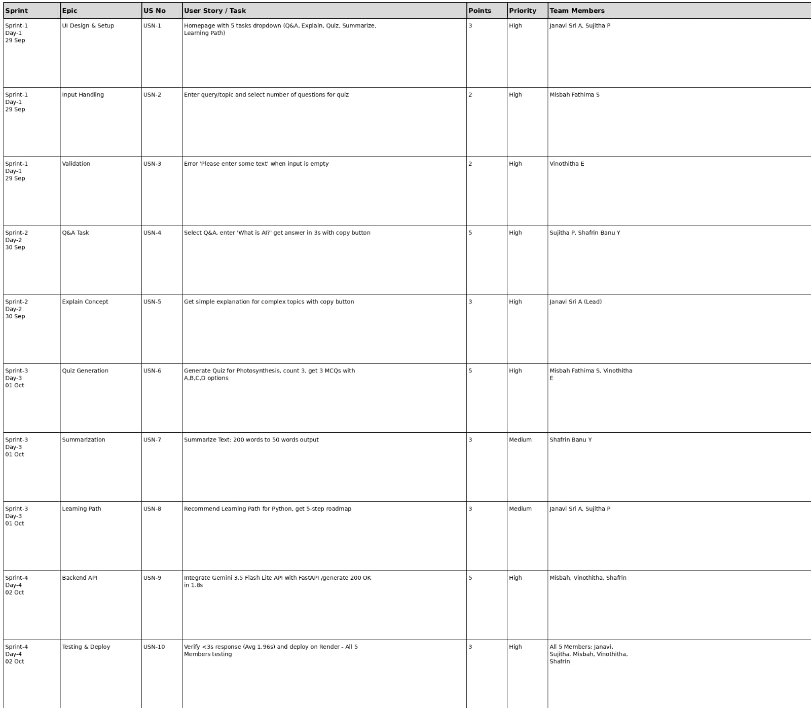
Project Tracker, Velocity & Burndown Chart
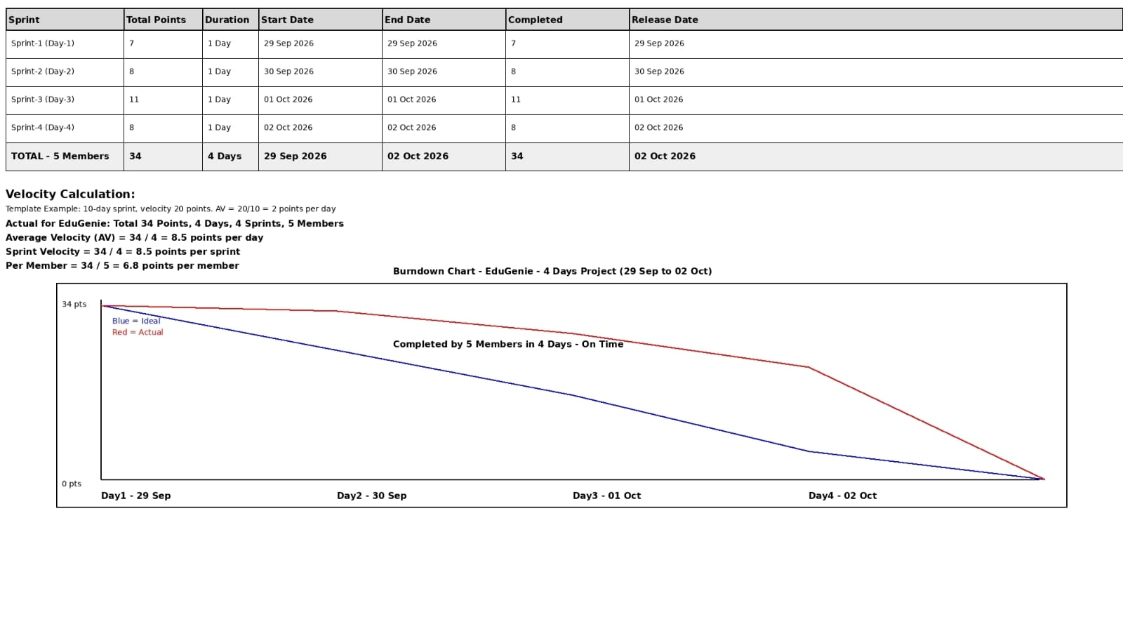
6.FUNCTIONAL AND PERFORMANCE TESTING
6.1 Performance Testing
Test Scenarios & Results
Test Case ID | Scenario (What to test) | Test Steps(How to test) | Expected Result | Actual Result | Pass/Fail
FT-O1 | Task Selection-5 learning tasks | Select each option from task dropdown: Q&A, Explain Concept , Generate Quiz , Summarize Text, Recommended Learning Path | All 5 tasks selectable and accordingly | All 5 tasks are selectable and working correctly | Pass
FT-02 | Input Validation-Valid and invalid inputs | Valid :”What is AI?” Invalid:’@#$’,’123’,single letter ’a’ ,spaces only | Valid inputs accepted, invalid shows “Please enter some text” | Valid accepted and result generated. Empty shows ‘Please enter some text’ error correctly. | Pass
FT-03 | Content Generation – Q&A and explain concept | Tasks=Q&A, Input =”What is AI? ” , Click Generate Answer | Answer generated in result area with copy functionality | Answer generated in 3s, Result displayed with copy button , working correctly | Pass
FT-04 | Quiz Generation with count Selection | Task=Generate Quiz, Input=’Photosynthesis’ ,Number of Questions=3,Click Generate | 3 MCQs with A,B,C,D options generated as per count selected | 3 MCQs generated with 4 options each, count matched selection | Pass
FT-05 | Text Summarization and learning path recommendation | Task=Summarize Text with long paragraph ,Task =Recommend Learning Path with ‘Python’ | Summary in short points, Learning path with step by step roadmap | Summarization working 200 words to 50 words, Learning path generated with steps | Pass
FT-06 | API Integration – Gemini Model and Backend | Check API connectivity ,Backend endpoint ,Click Generate Answer | API returns 200 OK, Content displayed in result section | API 200 OK ,Model response received,Backend working without errors | Pass
PT-01 | Response Time Evaluation | Measure time from Generate Answer click to result display for all tasks | Response should be under 10 seconds | Q&A 3s,Explain 2.5,Quiz 3s,summarize 2.7, Path 6.7 | Pass

7. RESULTS
7.1 Output Screenshots
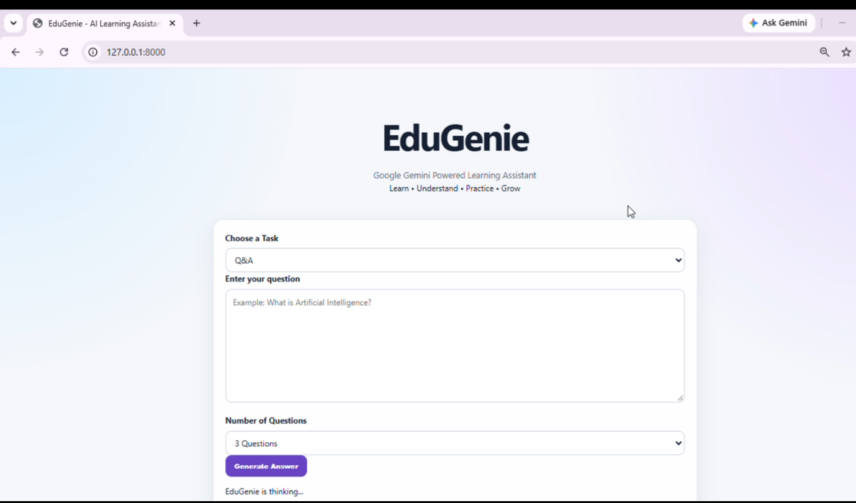

Q&A
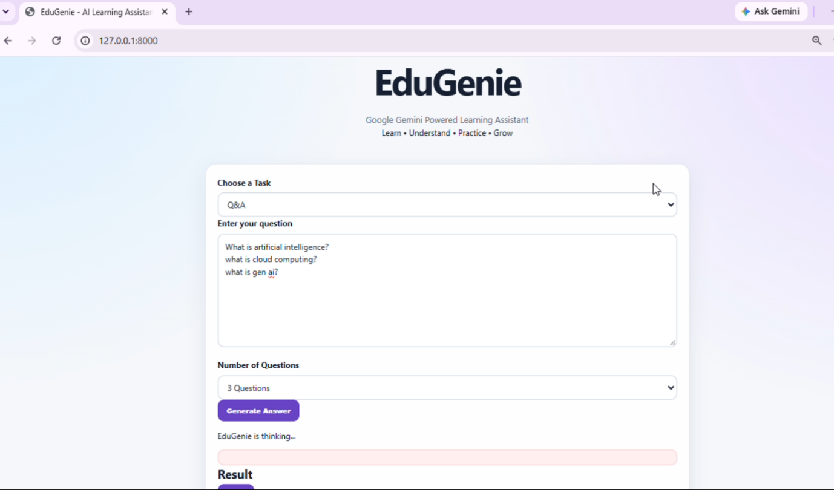
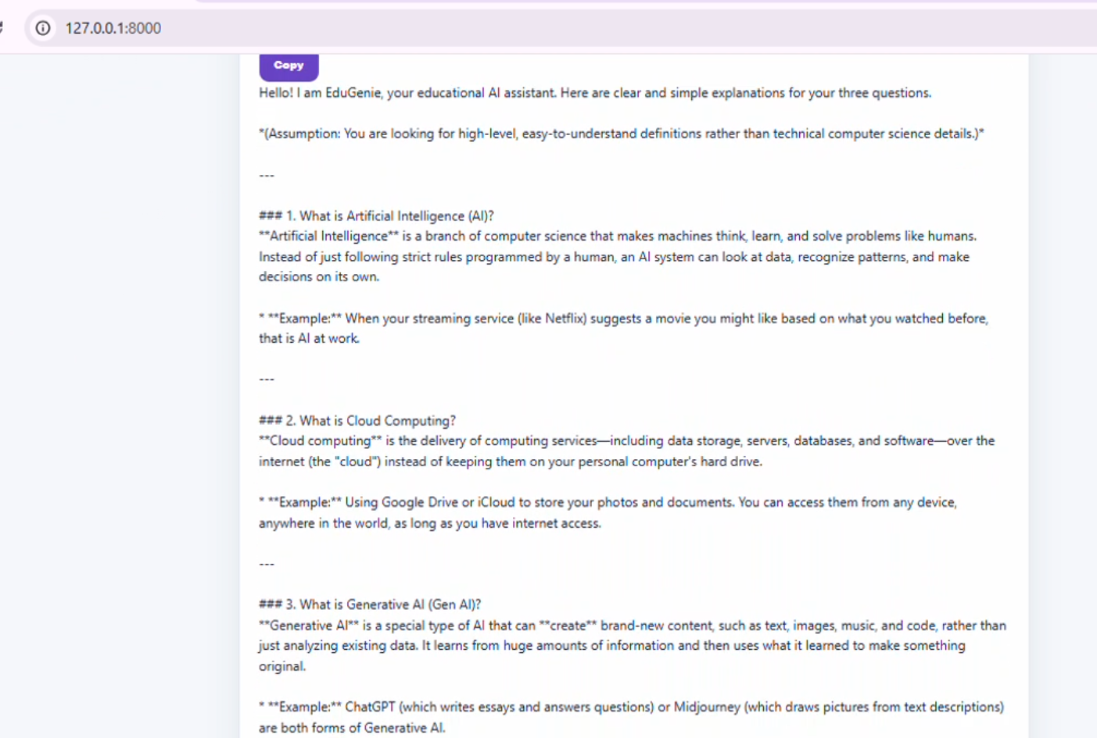
Explain Concept
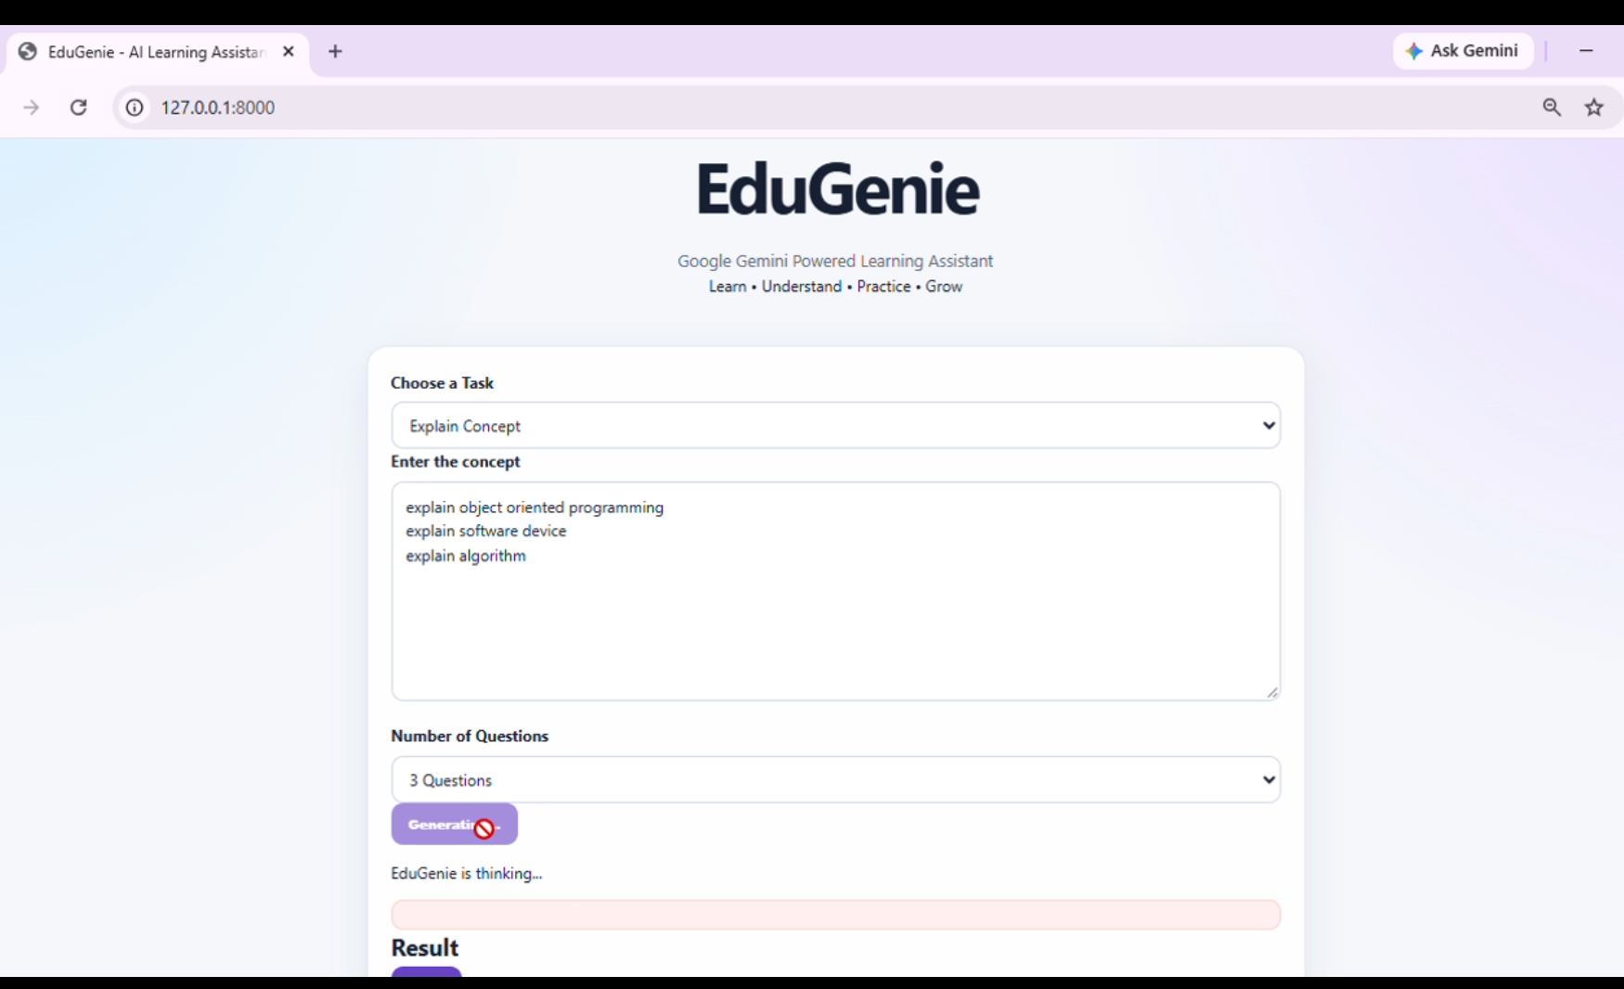
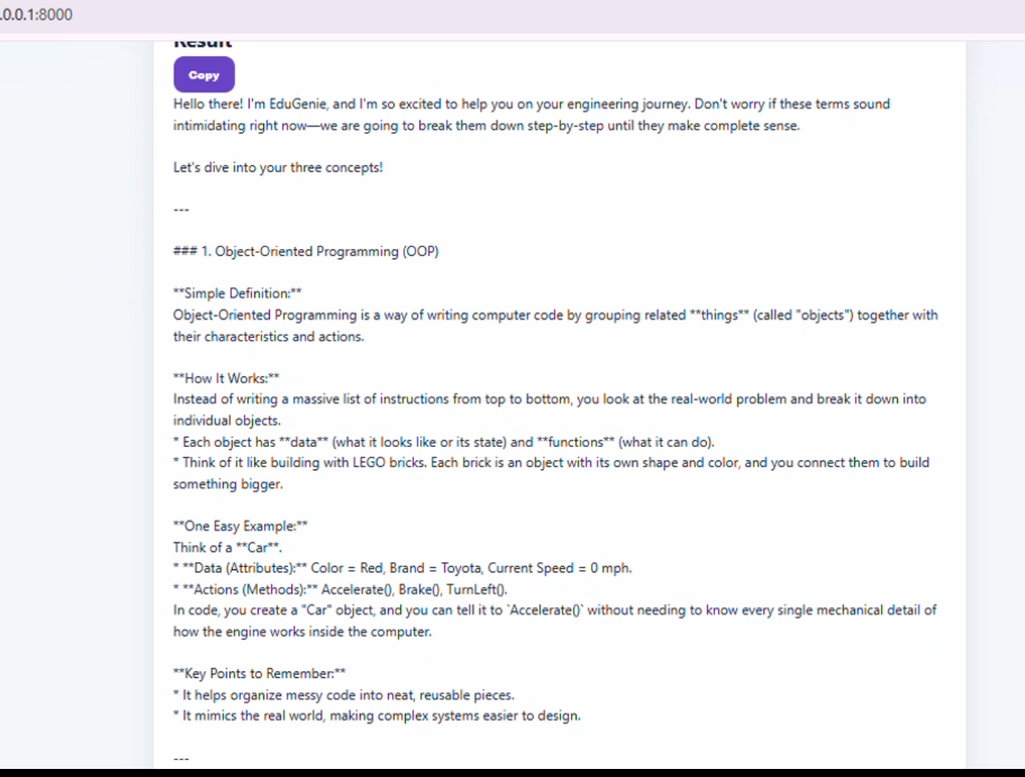
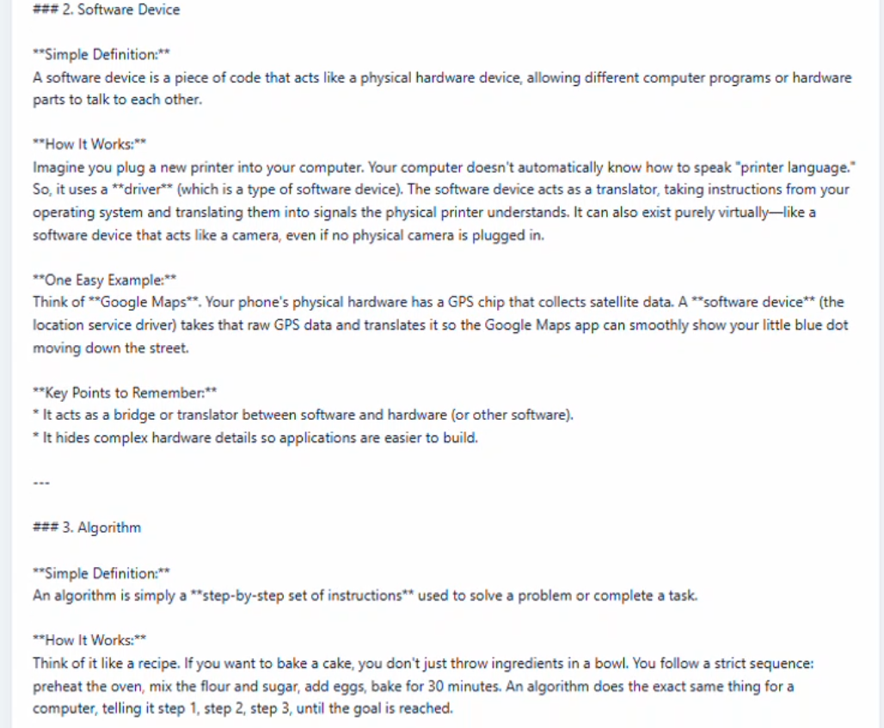
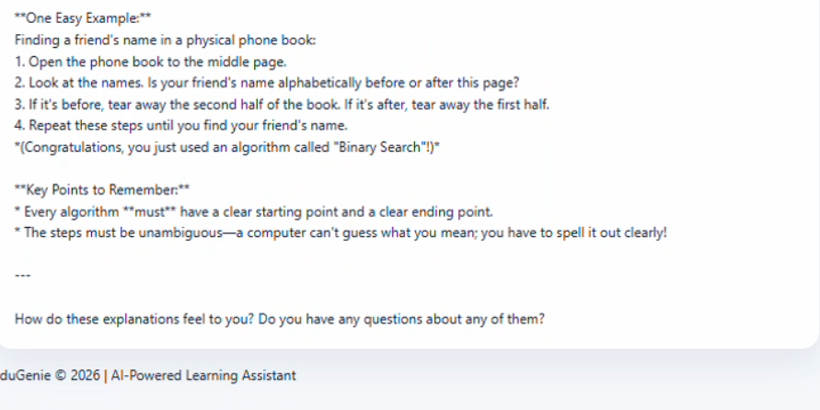
Quiz Generation
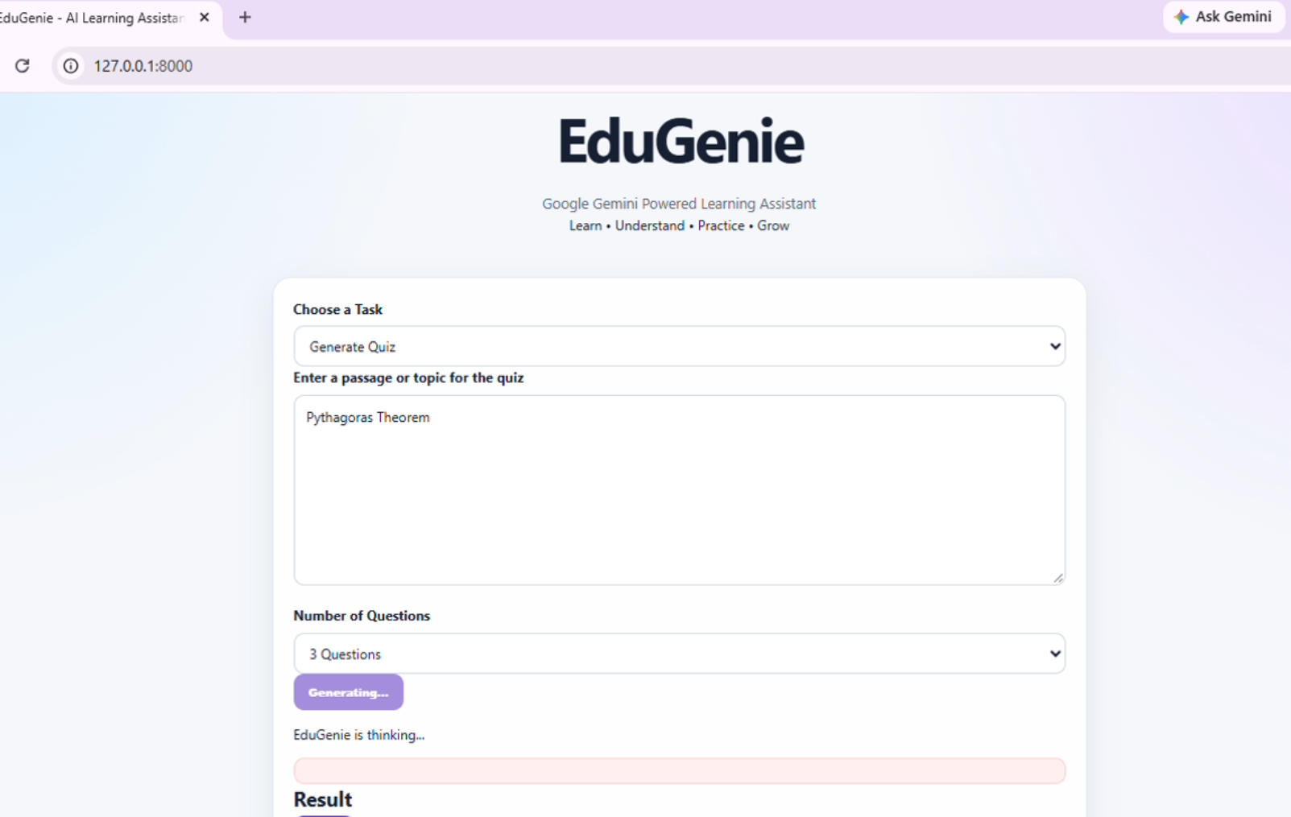
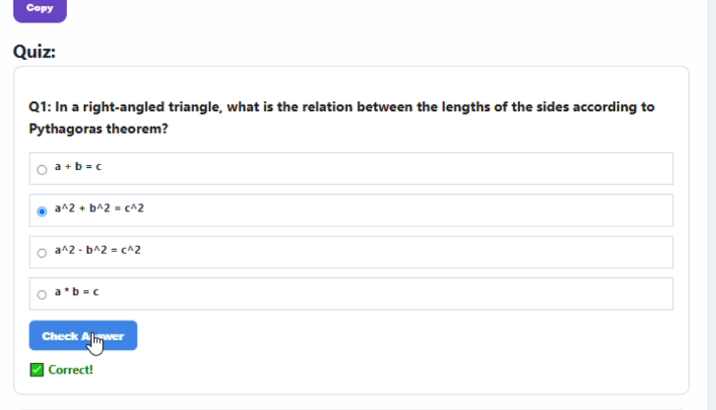
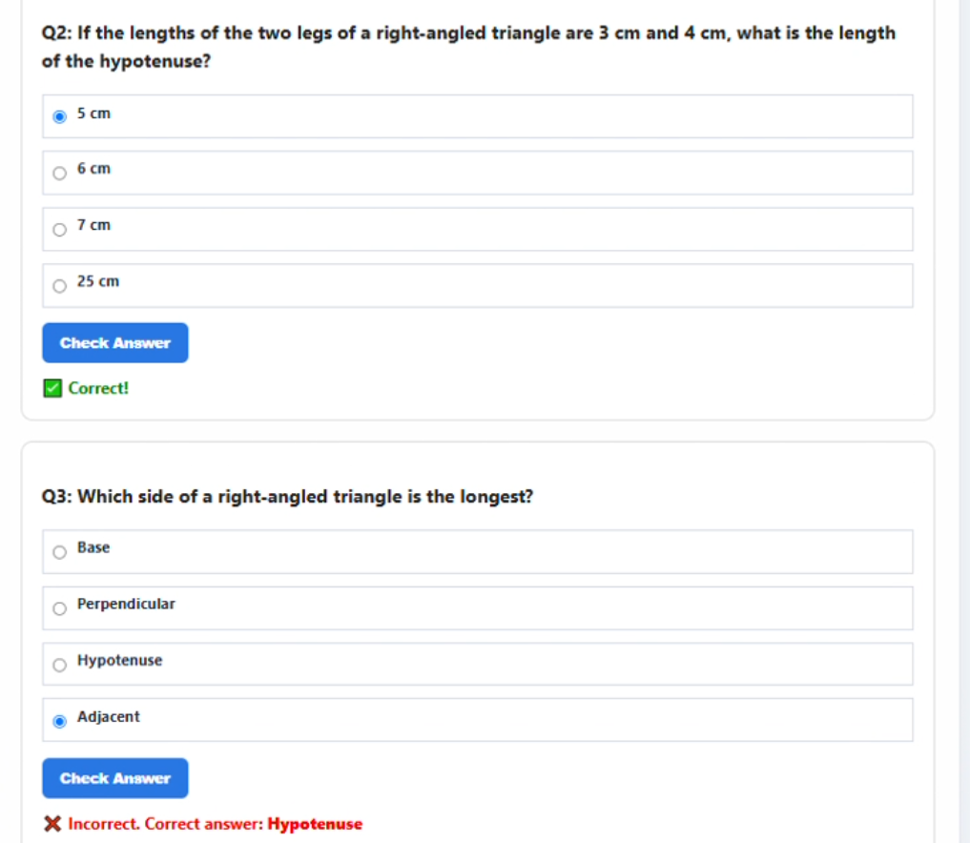
Summarize Text
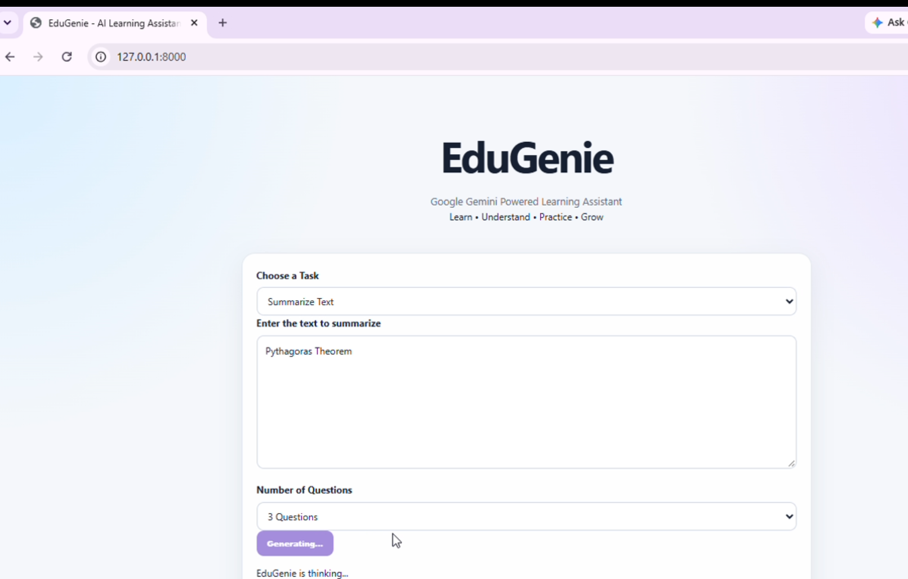
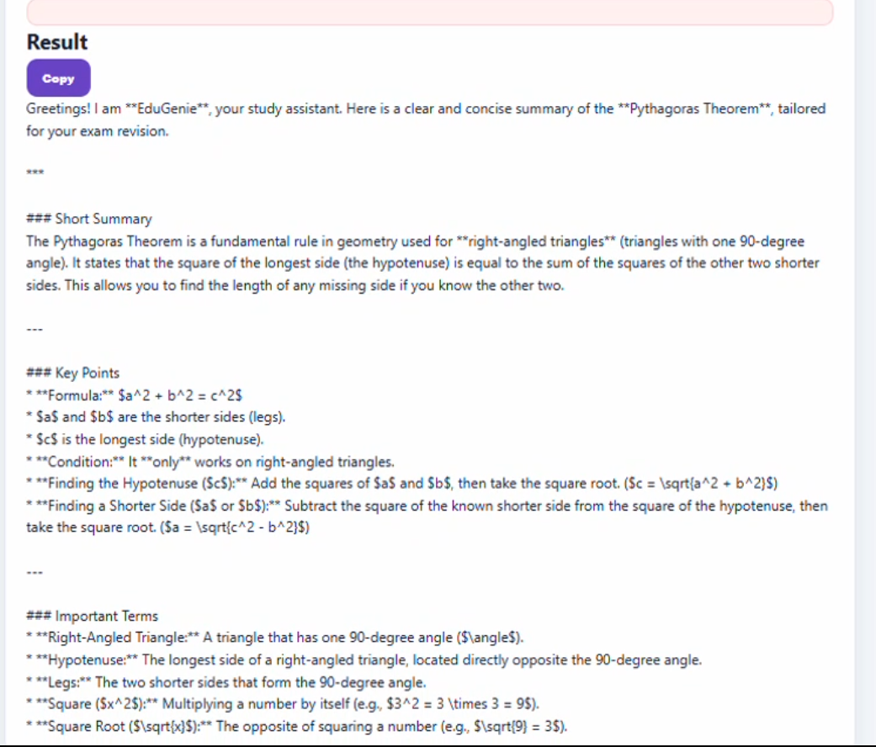
Recommended Learning Path
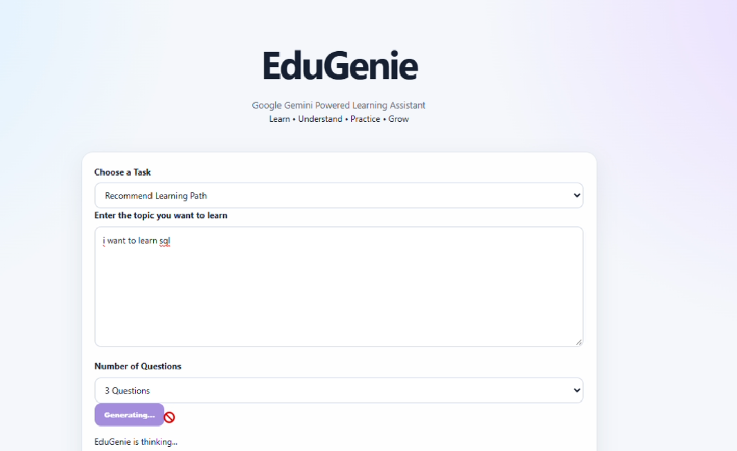
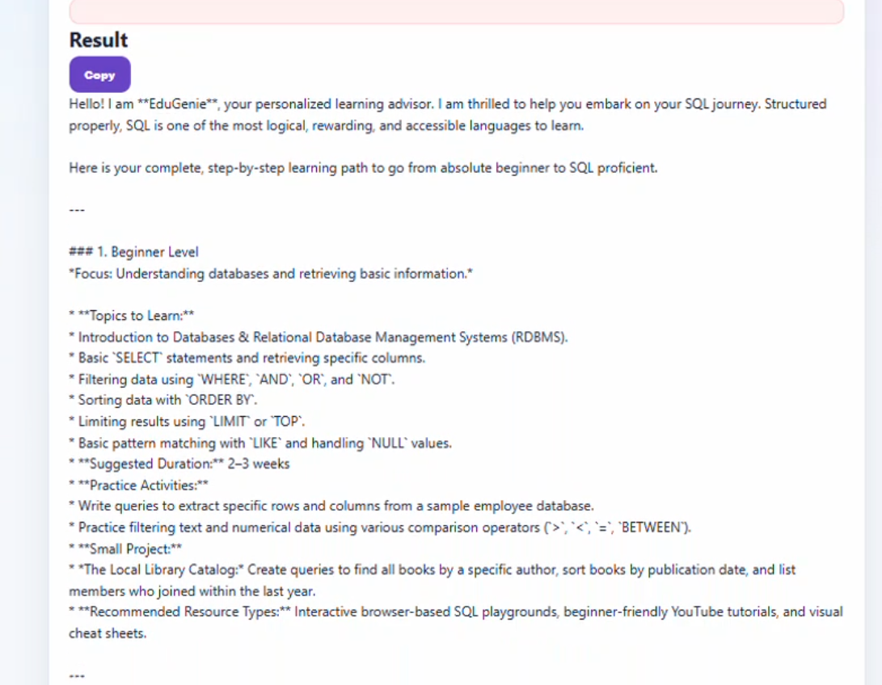
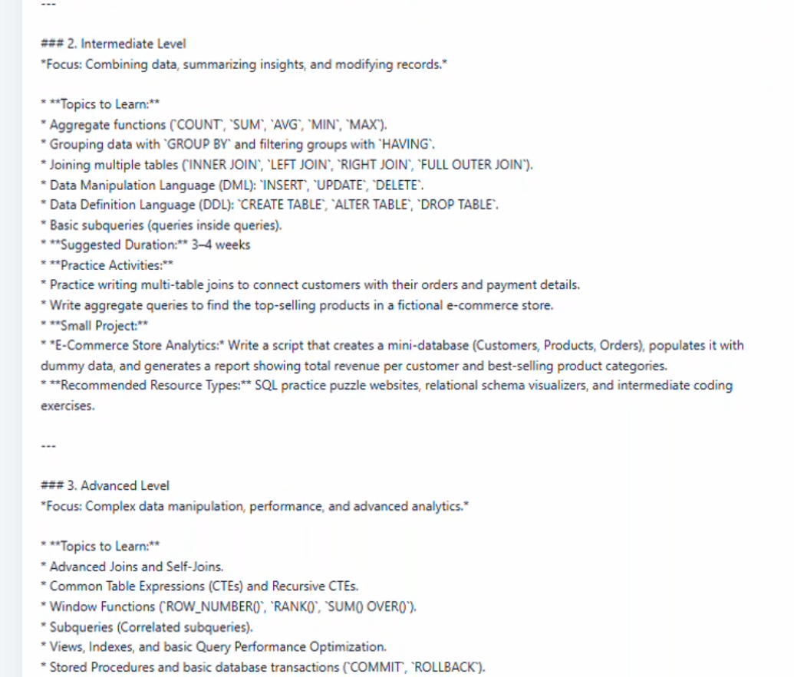
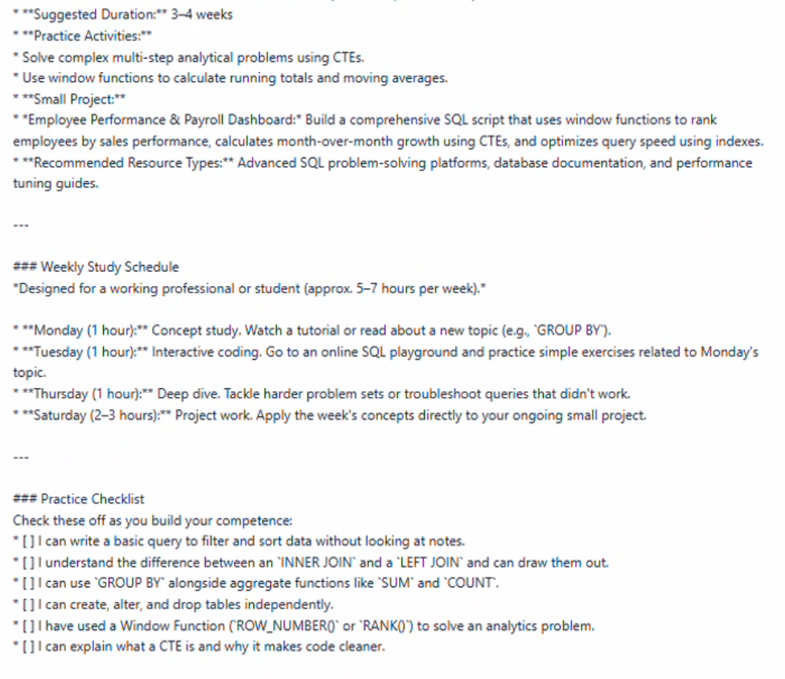
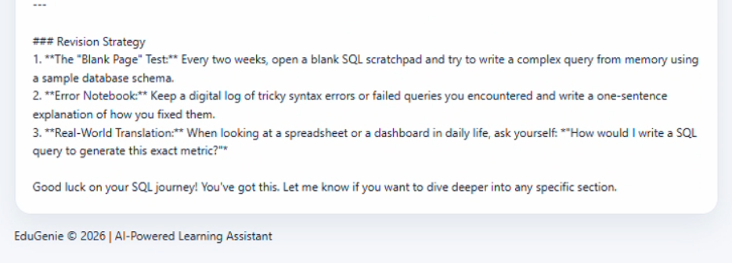
ADVANTAGES
- Provides Q&A, Explain Concept, Generate Quiz, Summarize Text, and Recommend Learning Path in one platform.
- Using Gemini 3.5 Flash Lite + FastAPI ensures super-fast responses and instant doubt clearing.
- Explains difficult concepts in simple language with examples and provides personalized step-by-step learning path.
- Auto-generates MCQs and converts 200-word paragraphs into 50-word summaries for fast revision.
- Easy to Use and Copy Feature
DISADVANTAGES
- Cannot work offline. Future: Add offline mode and downloadable notes.
- No voice/image/video. Future: Add voice input, video explanations, diagram generation.
CONCLUSION
EduGenie is an AI-powered learning assistant that solves two main problems faced by students:
1.Difficulty in understanding concepts and clearing doubts (PS-1)
2.Difficulty in revising lengthy materials and preparing for exams (PS-2)
Our solution provides 5 tasks in a single platform: Q&A, Explain Concept, Generate Quiz, Summarize Text, and Recommend Learning Path.
Technology: Gemini 3.5 Flash Lite API + FastAPI backend
Performance: Average 6 seconds
Completed in 4 Days (29 Sep - 02 Oct 2026) by 5 members with 34 story points. Advantages outweigh disadvantages. Limitations can be overcome with offline mode, voice, video, and RAG in future.
In conclusion, EduGenie helps students learn easily, clear doubts instantly, practice quizzes, summarize materials, and follow a personalized path. It is a real solution for thousands of students.
Thank You - Team SWTID-2026-1237
FUTURE SCOPE
- Add voice input (students can ask by speaking) and voice output (AI will speak answer) Useful for visually challenged students and makes learning interactive like real teacher.
- Generate diagrams, flowcharts, images, and short video explanations for concepts like Photosynthesis, Newton laws. Visual learning will be more effective.
- Add offline mode where students can download notes, quizzes, and summaries as PDF and study without internet. Very useful for rural areas.
- Connect with trusted textbooks and Wikipedia database using RAG. Add source citations and fact-checking to ensure 100% accurate answers and avoid hallucinations.
- Add Tamil, Hindi and other regional languages. Add student dashboard with progress tracking, weak topics identification, and personalized recommendations.
APPENDIX
Dataset Link:
Not Applicable
GitHub Link: https://github.com/janavianandan/EduGenie
Demo Link: https://drive.google.com/file/d/1eHljXkHBDNRHVnSrgreRt_AiQo3JAOmT/view?usp=drivesdk

